

**A Project report on**

**“Volo – Ecommerce website”**

**Submitted To**

Savitribai Phule Pune University

**Submitted By**

Arjun Jatav

Sakshi Kumari

**Under the Guidance of**

Prof. Yogita mam

**Department of “Bachelor of Computer Application”**

**Ness Wadia College of commerce Pune**

**ACADEMIC YEAR 2020-2021**

**SEMISTER IV**

**Introduction**

India is a developing country and Information Communication and technology are playing their important roles in development of the country. E-commerce means buying and selling of products or services over electronic systems such as the Internet and other computer networks. In India we have less ways to pay our bills online or trade online, so VOLO is Vocal for Local that encourages small business to sell or buy Goods or Services online. Not only this, VOLO also provides team services at doorstep to advertise your product or how to register your business online. Nowadays technology is very dynamic we need to adapt to this changes. VOLO website encourages small Indian businessman to explore e-commerce to increase their sells online. It helps to develop business & adapt themselves according to the changes. It will also contribute to India’s growth.

**Acknowledgement**

We are glad that we were able to complete this project and understand many things. Through preparation of this project was an immense learning experience and we inculcated many personal qualities during this process like responsibility, punctuality, confidence and others.

We would like to thank to our teachers who supported us all the time, cleared our doubts. We are taking this opportunity to acknowledge their support and we wish that they keep supporting us like this in the future.

A project is a bridge between theoretical and practical learning and with this thinking we worked on the project and made it successful due to timely support and efforts of all who helped me.

Once again, we would like to thank my Project Partner and Friends also for their encouragement and help in designing and making my project creative. We are in debt of all these. Only because of them we were able to create our project and make it good and enjoyable experience.

**Feasibility Study**

Feasibility Study in Software Engineering is a study to evaluate feasibility of proposed project or system. Feasibility study is carried out based on many purposes to analyze whether software product will be right in terms of development, implantation, contribution of project to the organization etc.

1. **Technical Feasibility**

* In Technical Feasibility current resources both hardware software along with required technology are analyzed/assessed to develop project. This technical feasibility study gives report whether there exists correct required resources and technologies which will be used for project development. Along with this, feasibility study also analyzes technical skills and capabilities of technical team, existing technology can be used or not, maintenance and up-gradation is easy or not for chosen technology etc.

1. **Operational Feasibility**

* In Operational Feasibility degree of providing service to requirements is analyzed along with how much easy product will be to operate and maintenance after deployment. Along with this other operational scopes are determining usability of product, Determining suggested solution by software development team is acceptable or not etc.

1. **Economic Feasibility**

* In Economic Feasibility study cost and benefit of the project is analyzed. Means under this feasibility study a detail analysis is carried out what will be cost of the project for development which includes all required cost for final development like hardware and software resource required, design and development cost and operational cost and so on. After that it is analyzed whether project will be beneficial in terms of finance for organization or not.

1. **Legal Feasibility**

* In Legal Feasibility study project is analyzed in legality point of view. This includes analyzing barriers of legal implementation of project, data protection acts or social media laws, project certificate, license, copyright etc. Overall it can be said that Legal Feasibility Study is study to know if proposed project conform legal and ethical requirements.

1. **Schedule Feasibility**

* In Schedule Feasibility Study mainly timelines/deadlines is analyzed for proposed project which includes how many times teams will take to complete final project which has a great impact on the organization as purpose of project may fail if it can’t be completed on time.

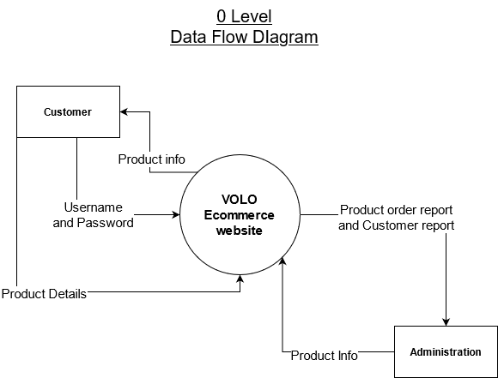

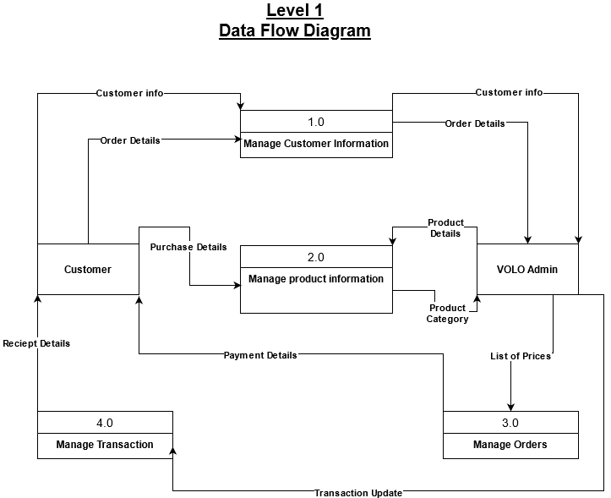

**Hardware and Software Requirement**

1. **Hardware Requirement:-**

The minimum requirements of hardware are as follows:

**Processor :** Intel(R) core(TM) i3-5005U CPU @ 2.00GHz 2.00GHz

**HDD:** 50 GB or above.

**RAM:** 512 RAM or above.

**Graphic card:** not necessary.

1. **Software requirement:-**

The minimum requirement of software is as follows:

**Operating system:** Windows XP or Higher

**Front end:** HTML, CSS, Java Script

**Back End:** mysql, Nodejs

**Document:** MS-Word

**Database Tables**

1. **Customer table**

|  |  |  |  |  |
| --- | --- | --- | --- | --- |
| **No.** | **Field name** | **Data type** | **Size** | **Constraints** |
| **1** | Cust_id | Number | 10 | Primary key |
| **2** | Username | Varchar | 20 | Not Null |
| **3** | First_name | Varchar | 20 | Not Null |
| **4** | Lastname | Varchar | 20 | Not Null |
| **5** | Email_id | Varchar | 30 | Not Null |
| **6** | Password | Varchar | 10 | Not Null |
| **7** | Mobile_no | Number | 10 | Not Null |
| **8** | Address | Varchar | 50 | Not Null |

1. **Payment table**

|  |  |  |  |  |
| --- | --- | --- | --- | --- |
| **No.** | **Field name** | **Data type** | **Size** | **Constraints** |
| **1** | Payment_id | Number | 10 | Primary key |
| **2** | Payment_type | Varchar | 20 | Not Null |
| **3** | Amount | Number | 10 | Not Null |

1. **Category table**

|  |  |  |  |  |
| --- | --- | --- | --- | --- |
| **No.** | **Field name** | **Data type** | **Size** | **Constraints** |
| **1** | Category_id | Number | 10 | Primary key |
| **2** | Category_name | Varchar | 30 | Not Null |

1. **Brands table**

|  |  |  |  |  |
| --- | --- | --- | --- | --- |
| **No.** | **Field name** | **Data type** | **Size** | **Constraints** |
| **1** | Brand_id | Number | 10 | Primary key |
| **2** | Brand_name | Varchar | 20 | Not |

1. **Products table**

|  |  |  |  |  |
| --- | --- | --- | --- | --- |
| **No.** | **Field name** | **Data type** | **Size** | **Constraints** |
| **1** | Product_id | Number | 10 | Primary key |
| **2** | Product_name | Varchar | 30 | Not Null |
| **3** | Product_model | Varchar | 20 | Not Null |
| **4** | Product_price | Number | 10 | Not Null |

1. **Cart table**

|  |  |  |  |  |
| --- | --- | --- | --- | --- |
| **No.** | **Field name** | **Data type** | **Size** | **Constraints** |
| **1** | Cart_id | Number | 10 | Primary key |
| **2** | Total_cost | Number | 10 | Not Null |

1. **Cart Item table**

|  |  |  |  |  |
| --- | --- | --- | --- | --- |
| **No.** | **Field name** | **Data type** | **Size** | **Constraints** |
| **1** | Cartitem_id | Number | 10 | Primary key |
| **2** | Quantity | Number | 5 | Not Null |
| **3** | Total_cost | Number | 10 | Not Null |

**Data Dictionary**

|  |  |  |  |  |
| --- | --- | --- | --- | --- |
| **No.** | **Field name** | **Data type** | **Size** | **Constraints** |
| **1** | Cust_id | Number | 10 | Primary key |
| **2** | Username | Varchar | 20 | Not Null |
| **3** | First_name | Varchar | 20 | Not Null |
| **4** | Lastname | Varchar | 20 | Not Null |
| **5** | Email_id | Varchar | 30 | Not Null |
| **6** | Password | Varchar | 10 | Not Null |
| **7** | Mobile_no | Number | 10 | Not Null |
| **8** | Address | Varchar | 50 | Not Null |
| **9** | Payment_id | Number | 10 | Primary key |
| **10** | Payment_type | Varchar | 20 | Not Null |
| **11** | Amount | Number | 10 | Not Null |
| **12** | Category_id | Number | 10 | Primary key |
| **13** | Category_name | Varchar | 30 | Not Null |
| **14** | Brand_id | Number | 10 | Primary key |
| **15** | Brand_name | Varchar | 20 | Not |
| **16** | Product_id | Number | 10 | Primary key |
| **17** | Product_name | Varchar | 30 | Not Null |
| **18** | Product_model | Varchar | 20 | Not Null |
| **19** | Product_price | Number | 10 | Not Null |
| **20** | Cart_id | Number | 10 | Primary key |
| **21** | Total_cost | Number | 10 | Not Null |
| **22** | Cartitem_id | Number | 10 | Primary key |
| **23** | Quantity | Number | 5 | Not Null |
| **24** | Total_cost | Number | 10 | Not Null |

**Screenshots**

**Home Page**

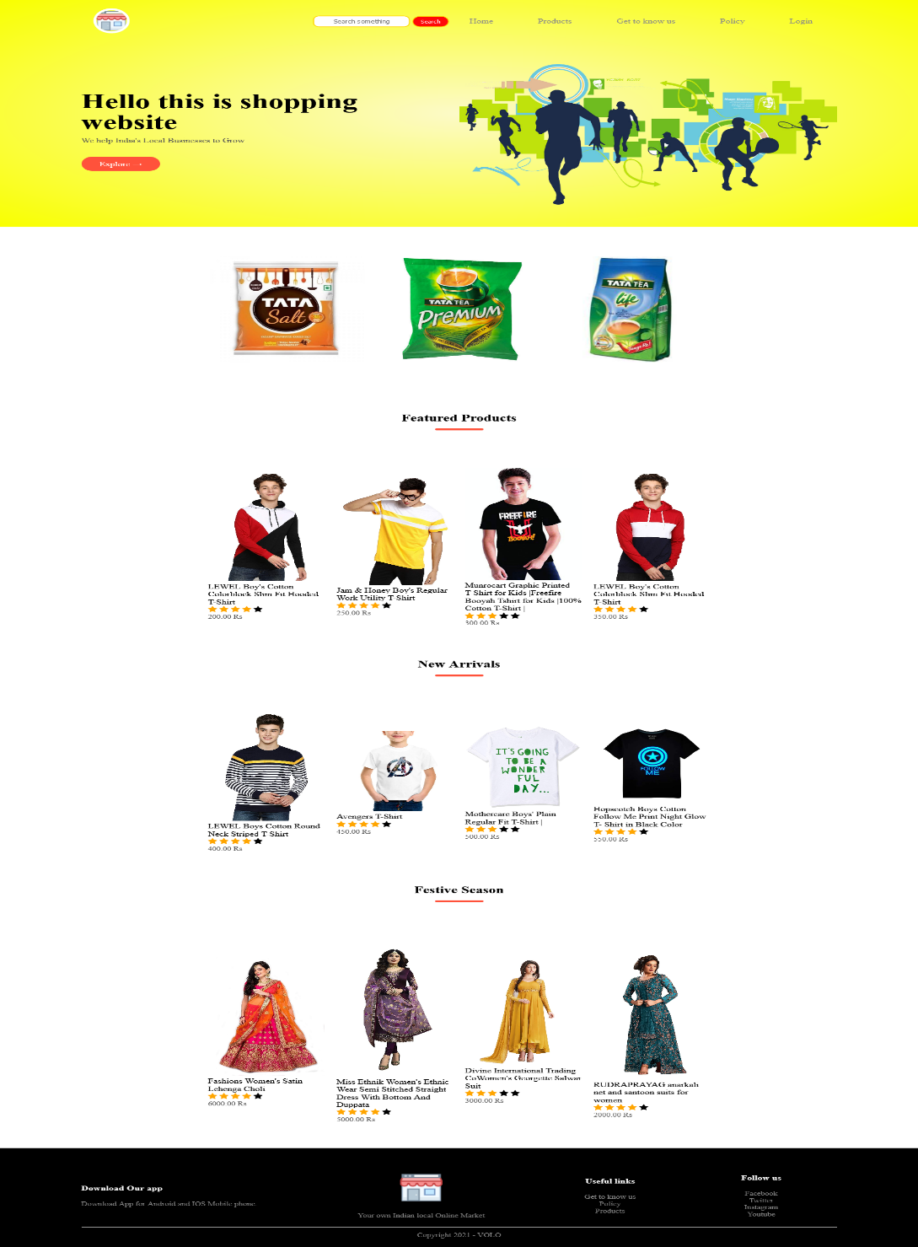

**Products**

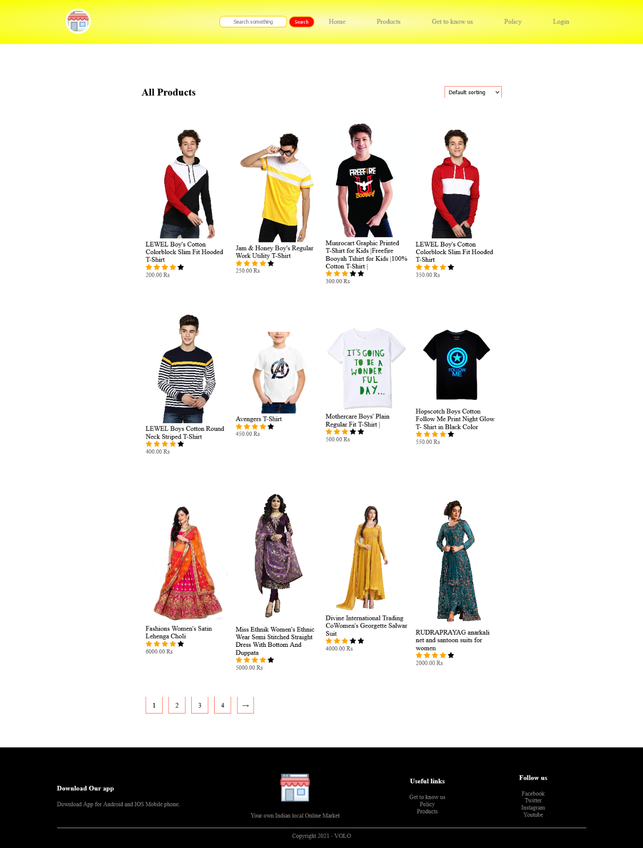

**Get to know us**

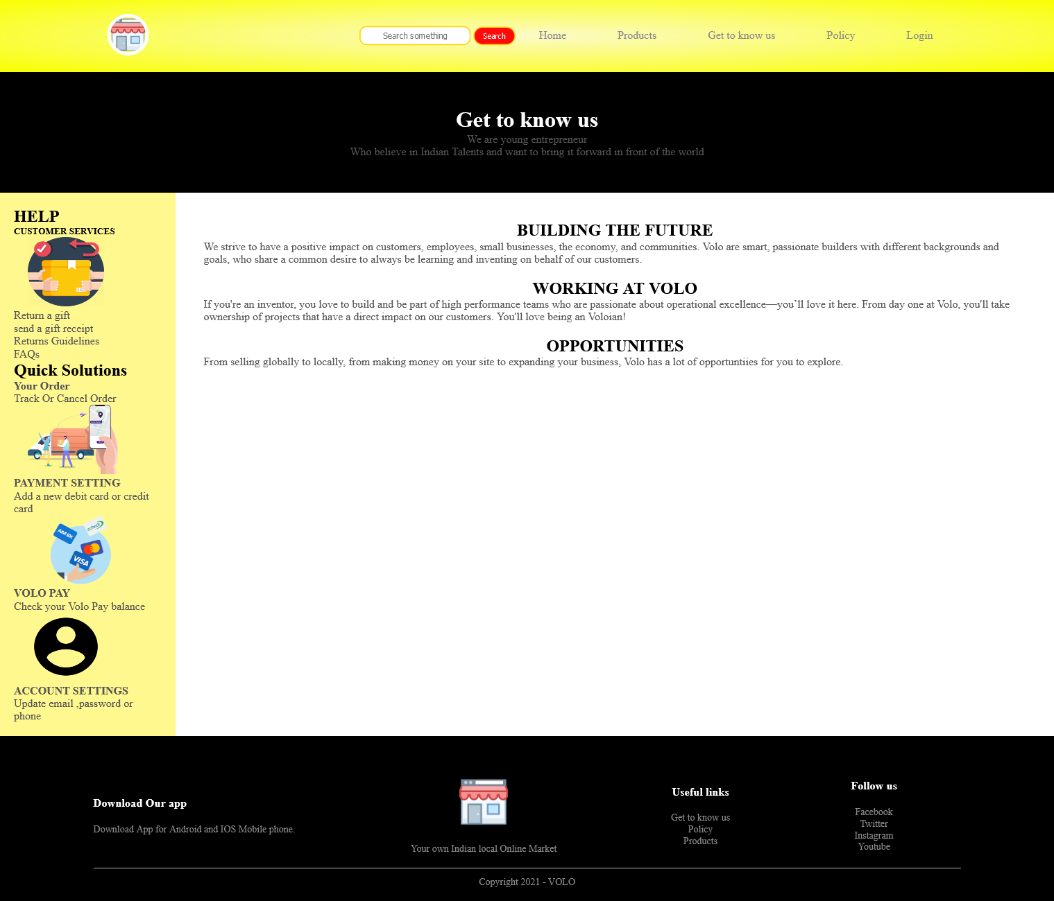

**Policy**

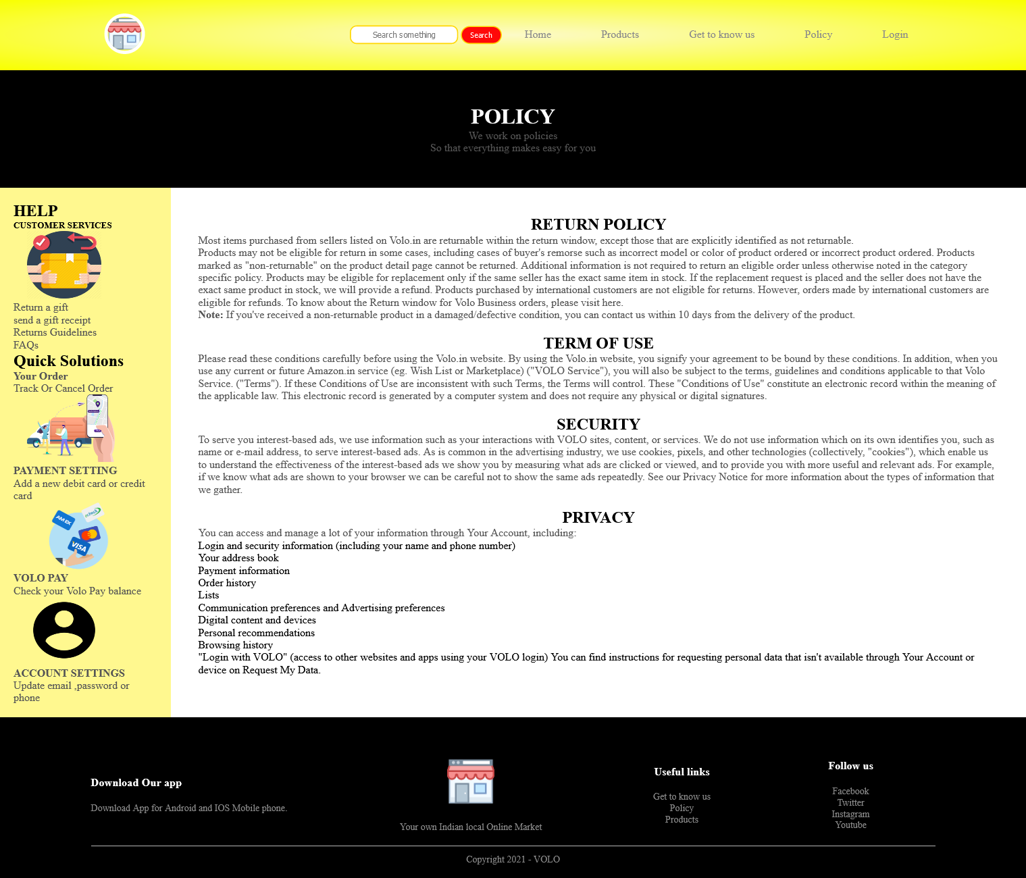

**Login**

